**User:**

I am a Mechanical Designer, proficient in SolidWorks drafting, and a recent graduate of the University of New South Wales. I would like you to act as both a knowledgeable designer who can provide me with design expertise and a professional engineering designer who can act as a technical advisor to me when I have complex questions.

I like the minimalist and sleek design style of the energy harvesting device. It should look clean and modern without unnecessary details.

The energy harvesting device is planned to be deployed in a coastal urban environment in Australia. The design needs to take into account the city where it will be applied to ensure consistent energy output throughout the year. Installation must be straightforward. In terms of maintenance, the unit should be designed to minimise the need for frequent repairs and, where necessary, key components should be easily accessible.

The equipment must comply with Australian Standards for Electrical Equipment. The design should be compact to fit into the limited urban space where the installation is specified. Considering the budget of A$50,000, we should prioritise durable materials, balancing cost and longevity.

Based on the above background, I will be designing an energy harvesting device.

The energy harvesting device shall require three key modules:

1. The energy accumulation module functions to derive energy from an external source outside the energy harvesting device.

2. The energy storage module functions to store the accumulated energy inside the energy

harvesting device.

3. The energy utilization module utilizes the harvested energy to power other small devices such as sensors, heating/cooling devices, actuators, and low-power devices.

Please give me as many and reasonable and complete designs as possible.

**GPT:**

Designing an energy harvesting device for a coastal urban environment in Australia, considering your requirements and constraints, is an exciting challenge. Let's break down the design aspects and considerations for each of the three key modules you've mentioned:

1. **Energy Accumulation Module:**
   * **Design Consideration:** Since the device will be in a coastal environment, the primary energy source could be solar, wind, or even tidal energy. Given the need for a sleek, minimalist design, solar panels could be a suitable choice. They are unobtrusive and can be integrated into urban structures.
   * **Materials:** Use high-efficiency, durable solar panels to maximize energy accumulation. The material should be corrosion-resistant to withstand coastal conditions.
   * **Structure:** Design panels to be adjustable for optimal sun exposure throughout the year. Include a self-cleaning mechanism to reduce maintenance needs.
2. **Energy Storage Module:**
   * **Design Consideration:** The storage unit needs to be compact yet efficient. Lithium-ion batteries are a good choice for their high energy density and longevity.
   * **Accessibility:** Place the battery unit in a location that is easily accessible for maintenance or replacement. Consider modular design for easy upgrades.
   * **Safety and Standards:** Ensure the design adheres to Australian Standards for Electrical Equipment, particularly in terms of battery safety and insulation.
3. **Energy Utilization Module:**
   * **Design Consideration:** This module should be versatile to power various small devices. It should include efficient converters and regulators to manage energy distribution.
   * **Connectivity:** Design the module with standard connectors for easy integration with a variety of devices. Include wireless connectivity options if feasible.
   * **Control System:** Implement a smart control system to monitor energy usage and optimize distribution based on device requirements.

**General Design Considerations:**

* **Aesthetics:** Maintain a sleek, modern look with clean lines. Use materials and colors that blend with the urban environment.
* **Budget:** Balance the use of high-quality materials with the A$50,000 budget. Prioritize durability to reduce long-term costs.
* **Installation:** Design the device to be modular and easy to install. Consider lightweight materials for easy handling.

**Final Thoughts:**

* Your design should embody a balance between form and function, catering to both aesthetic and practical needs.
* Consider incorporating smart technology for monitoring and managing the system efficiently.
* Sustainability should be a key factor, given the coastal urban setting and the purpose of the device.

Remember, iterative design and prototyping are key to refining your product. Keep in mind user feedback and real-world testing to make necessary adjustments.

**User:**

Based on the scenario you gave me above, please generate a visual concept diagram.

**GPT:**

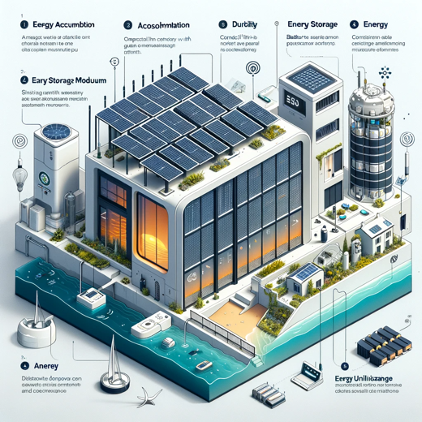

Here is a visual concept diagram that represents an urban coastal energy harvesting device with a sleek and minimalist design, incorporating the three key modules as described.